SPRINKLER SYSTEM INFORMATION SHEET 133 W 29th Street Ogden, Utah 84401
⁽⁸⁰¹⁾ ⁶²⁹⁻⁸³⁸⁴_{www.ogdencity.com}

Landscape sprinkler systems must be equipped with some type of approved backflow protection (Plumbing Code). Several types of backflow prevention devices or assemblies are available for use on landscape sprinkling systems. Below is a brief description of the types available.

ATMOSPHERIC VACUUM BREAKER
This is the most commonly used anti-siphon device. It consists of an atmospheric vent with an air poppet. The water source closes the air poppet allowing water to the downstream equipment. If water supply is lost or a negative pressure situation develops, this device allows air into the system to break the vacuum.
Atmospheric Vacuum Breakers (AVB) must be installed at least 6 inches above all downstream piping. An AVB cannot be installed below ground or in a pit. Shut off or control valves cannot be installed downstream of an AVB. A separate AVB would be required for each individual station of a sprinkler system. AVB's do not require testing and do not have to be reported to your local water supply agency.

PRESSURE ATMOSPHERIC VACUUM BREAKERS
This assembly has a spring loaded air poppet with an atmospheric vent and an independently acting spring loaded check valve. The assembly allows air into the system breaking the vacuum if the water supply is lost or a negative pressure situation develops. The check valve adds secondary protection. PVB's must be installed 12" above all downstream piping.

DOUBLE CHECK VALVE ASSEMBLY
A double check valve assembly (DCA) has two independently operating spring loaded check valves to prevent backflow from occurring. A DCA also has upstream and downstream shutoff valves and four appropriately placed test cocks. A DCA is approved for low health hazard applications only.
A January 1, 2006 change in the plumbing code does not allow a Double Check Valve assembly to be installed for lawn sprinkler systems.
http://sterlingcodifiers.com/codebook/index.php?book (Title 9-Chapter 4)
NOTE: Many suppliers offer a dual check valve device. This device consists of two spring loaded check valves but no shutoff valves or test cocks. This device is not approved for use in protecting against backflow from lawn sprinkling systems. It should not be used for this purpose!

REDUCED PRESSURE PRINCIPLE ASSEMBLY
A Reduced Pressure Principle assembly consists of two independently operating spring loaded check valves, a relief port venting to atmosphere, up and down stream isolation valves, and four appropriately placed test cocks.
A Reduced Pressure Principle {RP) assembly must be used on any sprinkling system utilizing chemical injection. Dual source (using both public drinking water system and irrigation or auxiliary water supplies) sprinkling systems are required to use a RP assembly and follow additional requirements established to prevent the systems from being physically connected together. RP's must be installed a minimum of 12 inches above ground.
PLEASE NOTE! All PVB, DCA and RP backflow prevention assemblies must be tested within ten days of initial use and annually thereafter by a commercially available certified backflow technician. Your local water purveyor (drinking water supply agency) must be notified of the installation and/or location of all testable Backflow prevention assemblies (PVB, DCA, and RP) within their water service area! Your local water purveyor is required by law to maintain an inventory record of all testable backflow prevention assemblies. They are also required to maintain copies of test results and repairs of all assemblies on inventory.
Ogden City does not enforce backflow testing of residents, but we highly encourage it.
(Most commercially available backflow technicians charge between $50.00 and $75.00 to test backflow prevention assembly. The cost of installation, maintenance and testing of an assembly is the responsibility of the owner.)
Please go to website shown below to view Ogden City's cross-connection ordinance. If you have any questions regarding backflow assemblies, please call our Backflow Technician at 801-629-8334.
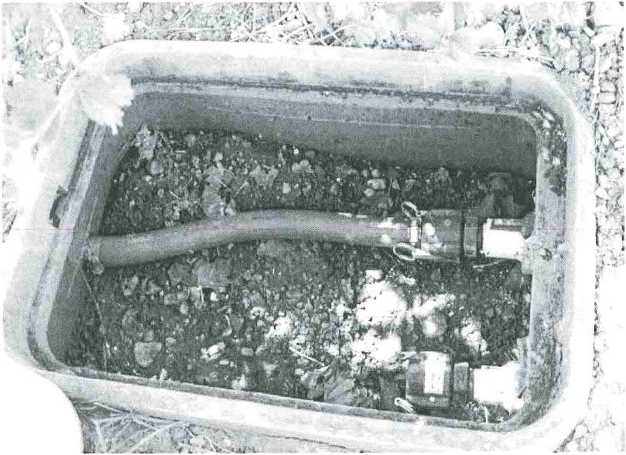

Swing Joint Connection
(Required on irrigation systems that use Secondary or Culinary water)
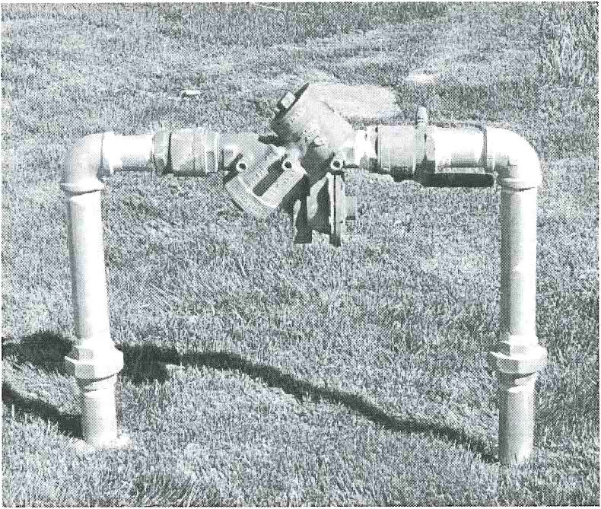

Reduced Pressure Zone Assembly (RP, RPZ, RPZA)
(Required on all irrigation systems. RP must have 12” clearance from the bottom relief port to the ground, and 12” around the assembly to allow for easy access. Assembly must be tested annually by a
certified technician.)

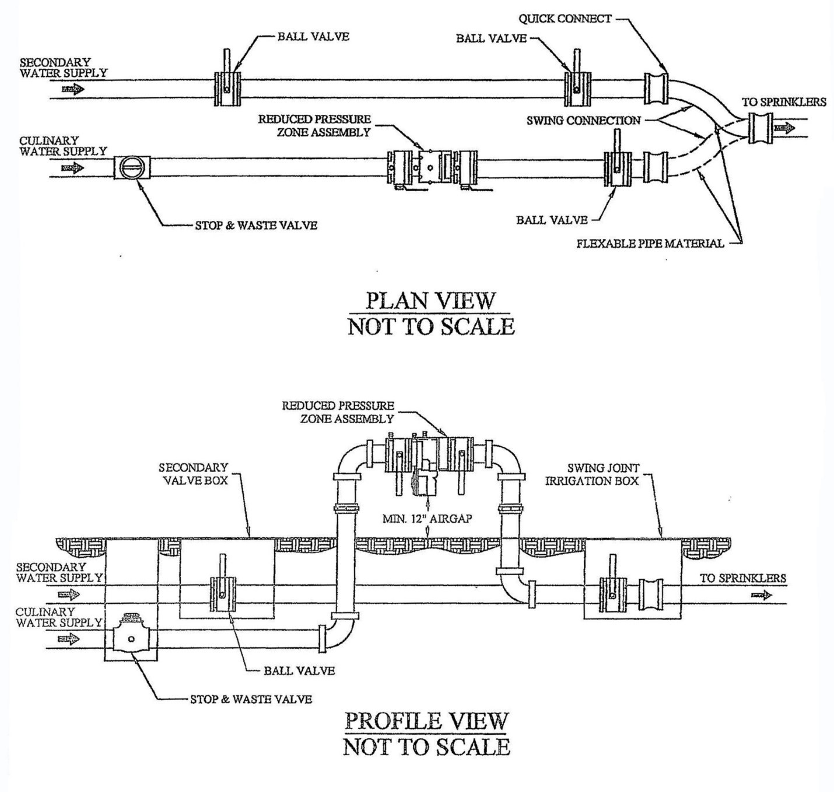
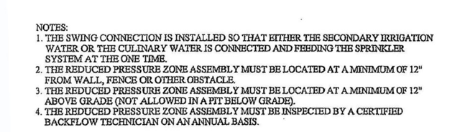
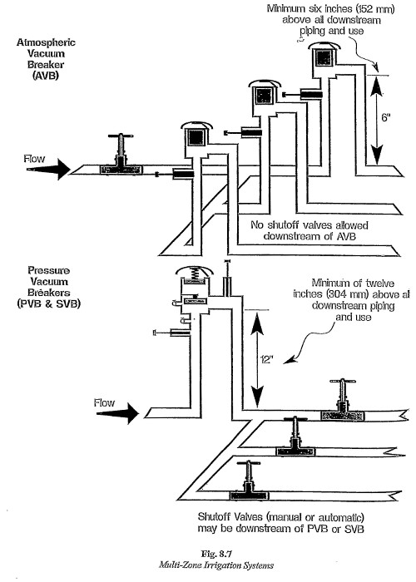

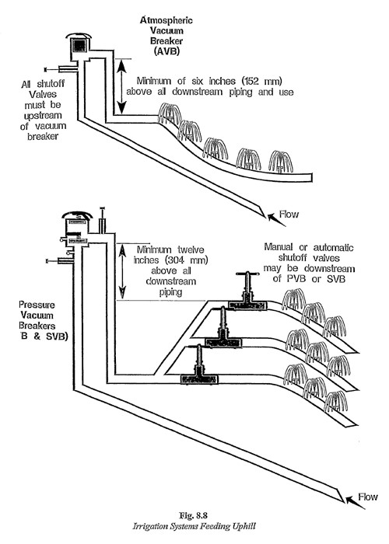

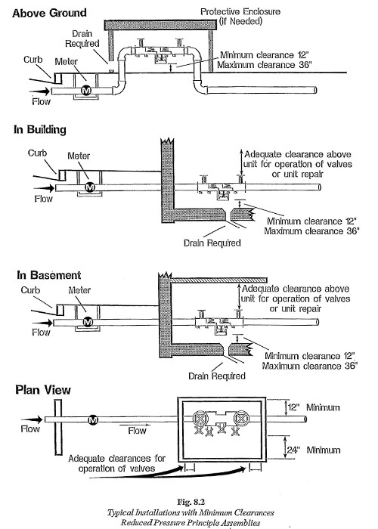

Thank you for requesting a sprinkler system information packet. One of the requirements Utah Division of Drinking Water impose on all water purveyors, is that they have a program for identifying and eliminating cross connections to the potable water system.
Our goal is to assure our residents safe drinking water and we believe that our program to identify and eliminate any possible cross connections is a vital link towards this goal. We want to assure our customers that the very last user on our water line has water that is just as safe as the very first user and that nothing has entered the system in between.
Regards,
Cross-Connection Control Staff

